Name -A.Akanksha
H.No - 2303A53004 – B46

Lab 7: Error Debugging with AI: Systematic approaches to finding and fixing bugs
Lab Objectives:
- To identify and correct syntax, logic, and runtime errors in Python programs using AI tools.
- To understand common programming bugs and AI-assisted debugging suggestions.
- To evaluate how AI explains, detects, and fixes different types of coding errors.
- To build confidence in using AI to perform structured debugging practices.
Lab Outcomes (LOs):
After completing this lab, students will be able to:
- Use AI tools to detect and correct syntax, logic, and runtime errors.
- Interpret AI-suggested bug fixes and explanations.
- Apply systematic debugging strategies supported by AIgenerated insights.
- Refactor buggy code using responsible and reliable programming patterns.

Task Description #1 (Syntax Errors – Missing Parentheses in Print Statement)
Task: Provide a Python snippet with a missing parenthesis in a print statement (e.g., print "Hello"). Use AI to detect and fix the syntax error.
# Bug: Missing parentheses in print statement def greet():
print "Hello, AI Debugging Lab!"
greet()
Requirements:
- Run the given code to observe the error.
- Apply AI suggestions to correct the syntax.
- Use at least 3 assert test cases to confirm the corrected code works.
Expected Output #1:
- Corrected code with proper syntax and AI explanation.
PROMPT:
#Detect and fix the syntax error in this Python code:
#def greet(): print 'Hello, AI Debugging Lab!' ; greet() #Explain the issue, provide corrected Python 3 code, and include 3 assert tests to verify correct output.
CODE:
def greet(): print('Hello, AI Debugging Lab!')
greet()
# The issue in the original code is that it uses Python 2 syntax for the print statement. In Python 3, print is a function and requires parentheses.
# Assert tests to verify correct output import io import sys def test_greet(): captured_output = io.StringIO() # Create StringIO object
sys.stdout = captured_output # Redirect stdout. greet() # Call the function. sys.stdout = sys.__stdout__ # Reset redirect.
assert captured_output.getvalue().strip() == 'Hello, AI Debugging Lab!' test_greet() def test_greet_output(): captured_output = io.StringIO()
sys.stdout = captured_output
greet()
sys.stdout = sys.__stdout__
assert captured_output.getvalue() == 'Hello, AI Debugging Lab!
\n'
test_greet_output() def test_greet_no_extra_output(): captured_output = io.StringIO()
sys.stdout = captured_output
greet()
sys.stdout = sys.__stdout__
assert captured_output.getvalue().count('Hello, AI Debugging Lab!') == 1 test_greet_no_extra_output()
OUTPUT:
Hello, AI Debugging Lab! AI Explanation:
The issue in the original code is that it uses Python 2 syntax for the print statement. In Python 3, print is a function and requires parentheses.
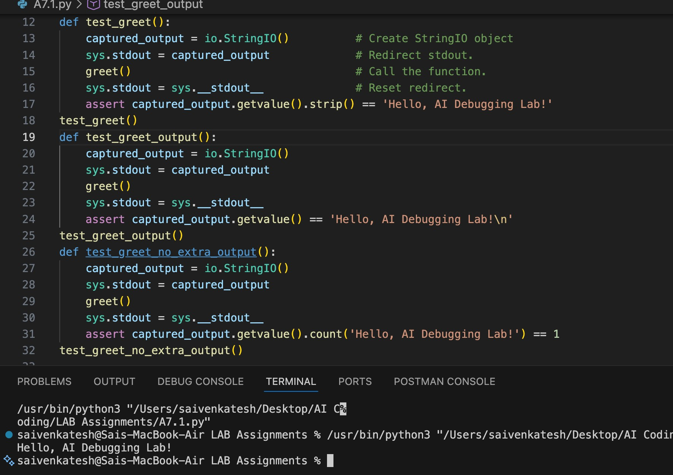
Task Description #2 (Incorrect condition in an If Statement)
Task: Supply a function where an if-condition mistakenly uses = instead of ==. Let AI identify and fix the issue.
# Bug: Using assignment (=) instead of comparison (==) def check_number(n): if n = 10:
return "Ten" else:
return "Not Ten" Requirements:
- Ask AI to explain why this causes a bug.
- Correct the code and verify with 3 assert test cases. Expected Output #2:
- Corrected code using == with explanation and successful test execution.

PROMPT:
#Detect and fix the error in this Python code: def check_number(n): if n = 10: return "Ten" else: return "Not Ten". #Explain why using '=' causes a bug, provide corrected code using '==', and include 3 assert tests to verify the function works. CODE:
def check_number(n):
if n == 10: return "Ten" else:
return "Not Ten"
# Assert tests
assert check_number(10) == "Ten" assert check_number(5) == "Not Ten" assert check_number(0) == "Not Ten" print("All tests passed!")
OUTPUT:
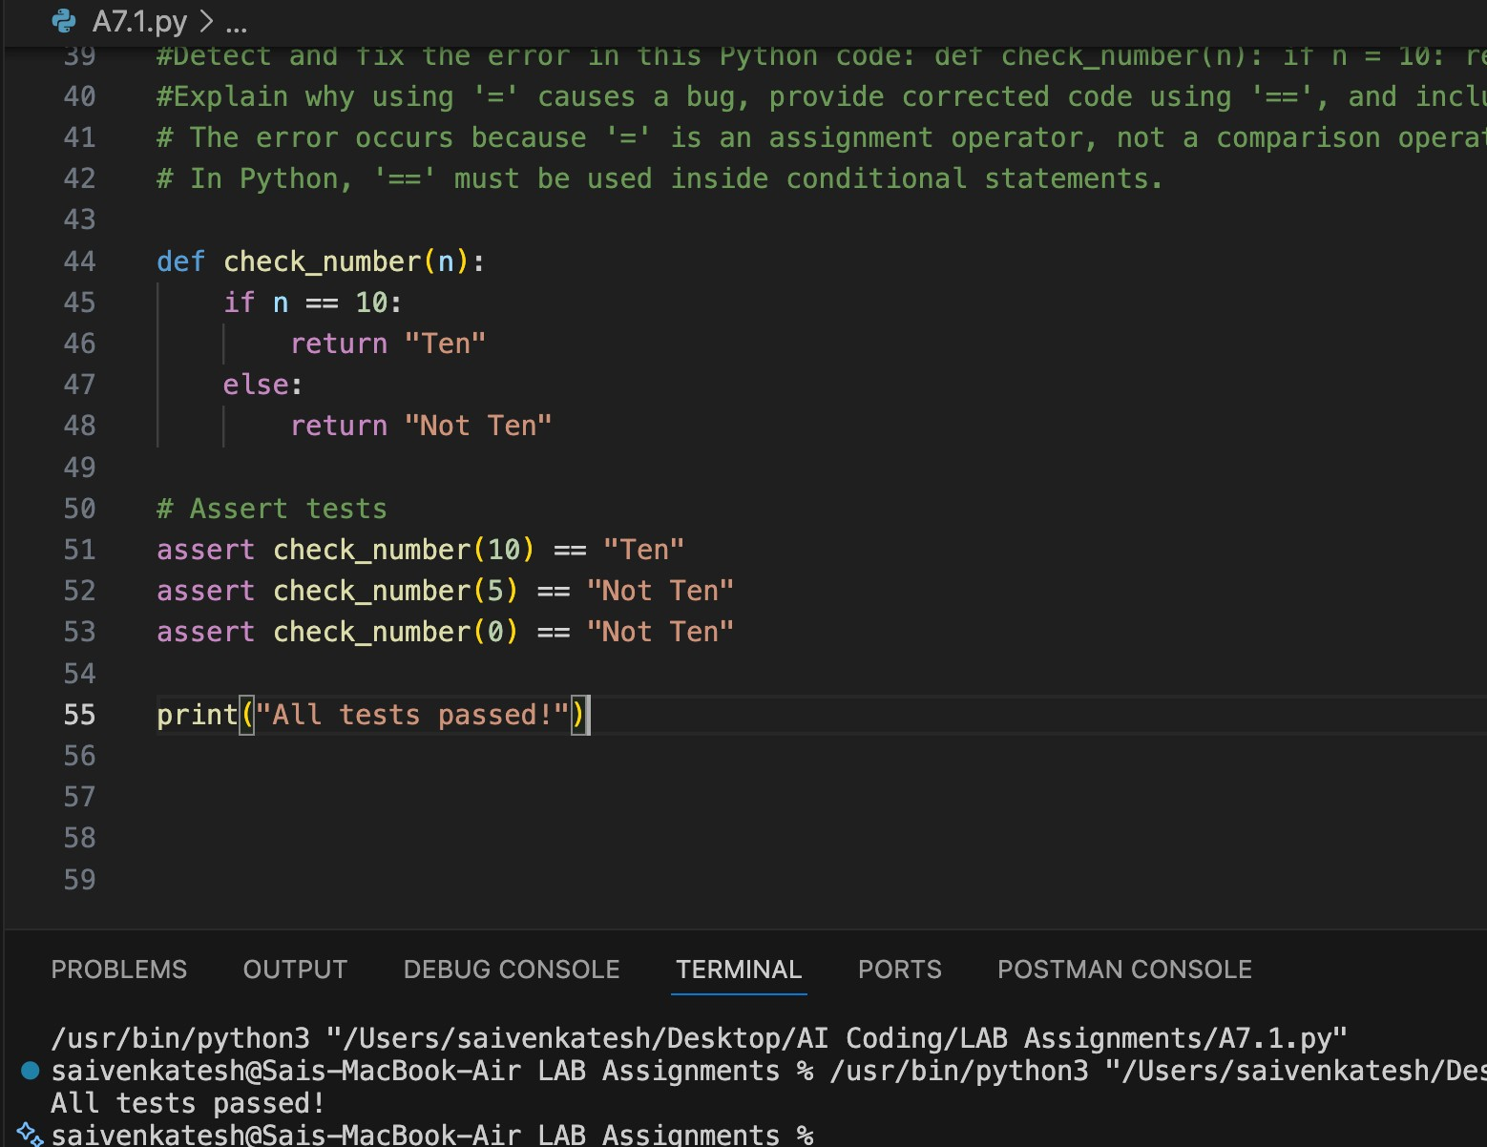
All tests passed!
EXPLAINATION
The error occurs because = is an assignment operator, not a comparison operator. In an if condition, Python requires == to compare values, and using = causes a SyntaxError. Replacing = with == correctly checks whether n is equal to 10, allowing the function to work properly.
Task Description #3 (Runtime Error – File Not Found)
Task: Provide code that attempts to open a non-existent file and crashes. Use AI to apply safe error handling.
# Bug: Program crashes if file is missing def read_file(filename):
with open(filename, 'r') as f: return f.read() print(read_file("nonexistent.txt"))
Requirements:
- Implement a try-except block suggested by AI.
- Add a user-friendly error message.
- Test with at least 3 scenarios: file exists, file missing, invalid path.
Expected Output #3:
- Safe file handling with exception management.
PROMPT:
#Analyze this Python code that crashes when a file does not exist: def read_file(filename): with open(filename,'r') as f: return f.read()
#Fix the runtime error using try–except, add a user-friendly error message, and include 3 assert tests for file exists, file missing, and invalid path cases.
CODE:
def read_file(filename):
try:
with open(filename, 'r') as f: return f.read()
except FileNotFoundError: return "File not found." print(read_file("nonexistent.txt"))
# Assert tests
assert read_file("nonexistent.txt") == "File not found." # To test the function with an existing file, we can create a temporary file and write some content to it. import tempfile
with tempfile.NamedTemporaryFile(delete=False) as tmp: tmp.write(b"Hello, World!") tmp_filename = tmp.name
assert read_file(tmp_filename) == "Hello, World!" import os os.remove(tmp_filename) # Test with an empty file
with tempfile.NamedTemporaryFile(delete=False) as tmp: tmp_filename = tmp.name assert read_file(tmp_filename) == "" os.remove(tmp_filename)
OUTPUT
File not found.
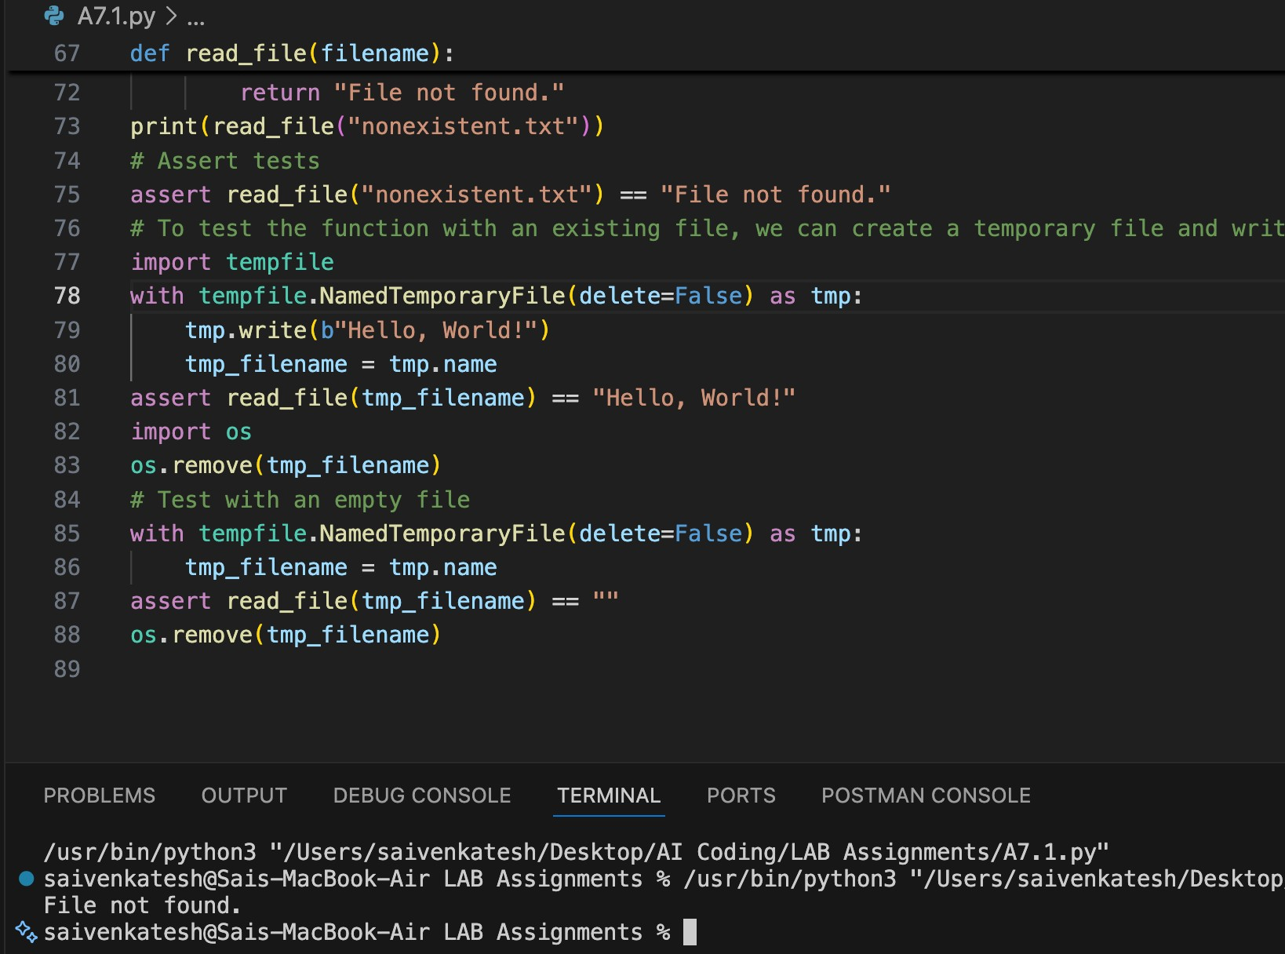
EXPLAINATION:
The program crashes because it tries to open a file that does not exist, which raises a FileNotFoundError. By using a try–except block, the exception is caught and handled safely instead of stopping the program. This allows the function to return a userfriendly error message while continuing execution.
Task Description #4 (Calling a Non-Existent Method)
Task: Give a class where a non-existent method is called (e.g., obj.undefined_method()). Use AI to debug and fix.
# Bug: Calling an undefined method class Car: def start(self): return "Car started"
my_car = Car()
print(my_car.drive()) # drive() is not defined
Requirements:
- Students must analyze whether to define the missing method or correct the method call.
- Use 3 assert tests to confirm the corrected class works.
Expected Output #4:
- Corrected class with clear AI explanation.
PROMPT:
#Detect and fix the error in this Python code where a nonexistent method is called: class Car: def start(self): return "Car started" my_car = Car(); print(my_car.drive())
#Explain the cause of the error, decide whether to define the missing method or correct the method call, provide corrected code, and include 3 assert tests to verify the class works properly.
CODE:
class Car:
def start(self):
return "Car started"

def drive(self): return "Car is driving"
my_car = Car() print(my_car.drive()) # Assert tests assert my_car.start() == "Car started" assert my_car.drive() == "Car is driving" another_car = Car() assert another_car.start() == "Car started" assert another_car.drive() == "Car is driving”
OUTPUT:
Car is driving
EXPLAINATION:
The error occurs because the method drive() is called on the Car object, but it is not defined in the Car class, which raises an
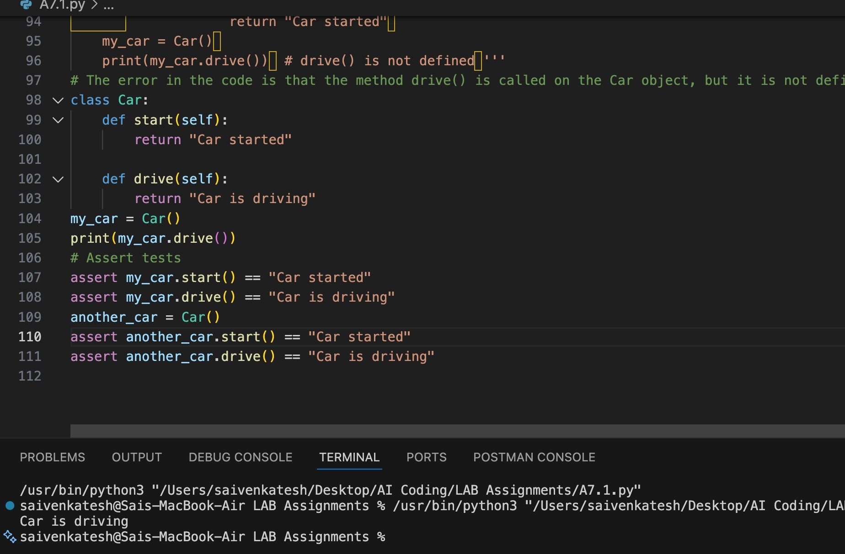
AttributeError. Python cannot execute a method that does not exist in the class. The issue is fixed by defining the missing drive() method (or correcting the method call), allowing the object to use the method successfully.
Task Description #5 (TypeError – Mixing Strings and Integers in Addition)
Task: Provide code that adds an integer and string ("5" + 2) causing a TypeError. Use AI to resolve the bug.
# Bug: TypeError due to mixing string and integer def add_five(value): return value + 5
print(add_five("10"))
Requirements:
- Ask AI for two solutions: type casting and string concatenation.
- Validate with 3 assert test cases.
Expected Output #5:
- Corrected code that runs successfully for multiple inputs.
PROMPT:
#Detect and fix the TypeError in this Python code caused by adding a string and an integer:
def add_five(value): return value + 5 ; print(add_five("10")) #Explain why the error occurs, provide two solutions (one using type casting for numeric addition and one using string concatenation), and include 3 assert tests to verify both solutions work correctly.
CODE:
def add_five_numeric(value): return int(value) + 5 print(add_five_numeric("10")) # Assert tests for numeric addition assert add_five_numeric("10") == 15 assert add_five_numeric("0") == 5 assert add_five_numeric("-5") == 0 # Solution 2: Using string concatenation def add_five_string(value): return value + "5" print(add_five_string("10"))
# Assert tests for string concatenation assert add_five_string("10") == "105" assert add_five_string("Hello") == "Hello5" assert add_five_string("") == “5"
OUTPUT:
15
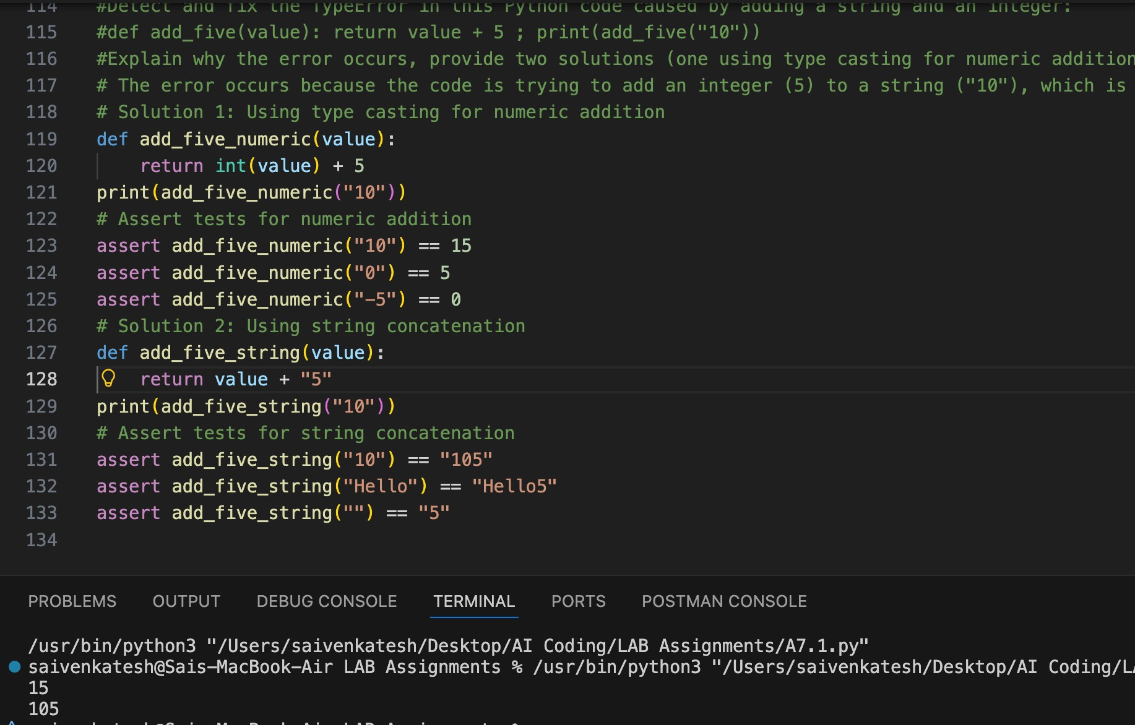
105
Explanation:
The error occurs because Python cannot add a string and an integer, which raises a TypeError. One solution is to convert the input to an integer using type casting so numeric addition can be performed. Another solution is to convert the value to a string and use string concatenation instead, depending on the intended behavior.

